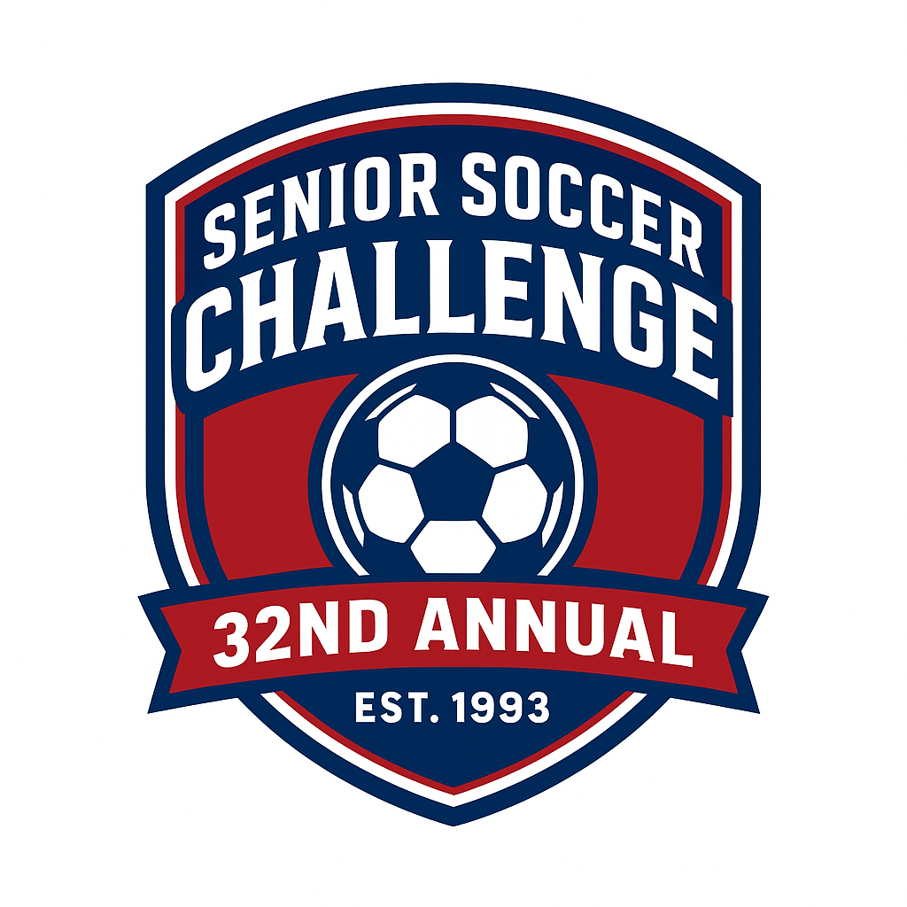
Over THIRTY years later….It’s still the Challenge!

Please Print Player’s Name Clearly: __________________________________________________________

AGREEMENT
PARENT: I give permission for my (son/daughter) to participate in the Senior Soccer Challenge. I assume all hazards and risks incidental to this participation, including transporting to and from these activities. I do hereby waive, release, absolve, indemnify and do hold harmless Senior Soccer Challenge, Inc., the organization, sponsors, supervisors, participants, volunteers, and any person involved in transporting my child to or from these activities from all claims arising out of an injury to my child.
PLAYER: I agree to attend practices and the game. If I am unable to attend, I will give my coach reasonable notice. I will behave in a manner that will reflect favorable on the organization, my school and my teammates. I will wear the uniform that is provided to me without making substitutions or alterations.
ORGANIZATION & COACHES: We agree to be fair and impartial when selecting the team and selecting winners for scholarships and awards, without regards to race, sex, or national origin. We will secure a site, organize the event, obtain sponsors, and meet all expenses and requirements as set for an IRS 50l(c)3, not for profit organization.
Parent: _____________________________________________ Date: _________________
Player: _____________________________________________ Date: _________________
Coach: _____________________________________________ Date: _________________
Organization: ________________________________________ Date: _________________

